SIT123: Data Capture Technologies

# Lab Report Week 2: Getting started with Sensors

In this task, we will attach sensors to the Arduino board, and collect sensor data. Similar to last week, we will use software engineering methods to plan and organise our exercise.

## Hardware Required

* Arduino Board
* USB cable
* HCSR505 PIR (Passive Infra Red) Motion Detector
* DHT22 Temperature and Humidity Sensor
* DFrobot Soil Moisture Sensor
* Male to Female Dupont Jumper Wires
* Male to Male Dupont Jumper Wires

## Software Required

Arduino programming environment

## Pre-requisites: You must do the following before this task

1. **Watched the lecture video**
2. **Read this sheet from top to bottom**

## **Task 1 - Objective**

**For this task, your tutor/lecturer will be your client. Here are your client’s requirements:**

* **“We have an Arduino board and some sensors. We need to be able to measure air temperature, humidity, motion, and soil moisture, and see the collected data in real-time on the computer screen.”**

## Task 1 - Submission Details

There are 4 questions in this task. Answer all of them in this word document itself.

### **Q1: Consider the given Task Objective. Think about how this simple system can be decomposed to ‘Sense-Think-Act’ as discussed in class (lecture).**

1. What is the ‘sensing’ requirement in this system, if any?

Sense motion, temperature, humidity and soil moisture changes

1. What is the ‘thinking’ requirement in this system, if any?

The Arduino board processes the data and outputs it onto the screen

1. What is the ‘acting’ requirement in this system, if any?

N/A

### **Q2: PIR Motion Detector**

Please refer to the provided ‘**Sensing Motion Activity Sheet**’ and follow the steps.

1. Refer to the given code in HCSR505motion.ino. What does the following line mean?

Serial.begin(9600);

This procedure sets the baud rate of the data transmission. In this case, we are setting the baud rate to 9600bps.

1. If the Arduino transfers data at 4800 bits per second and you're sending 12 bytes of data, how long does it take to send over this information?

It would take 20 milliseconds to send over the information

c) What is a simple strategy to test this program to make sure it is working as given in the requirements?

Print messages in the serial monitor to determine if the sensors are working correctly

d) Take a screenshot of your Serial Monitor displaying motion data logs. Add the image here. 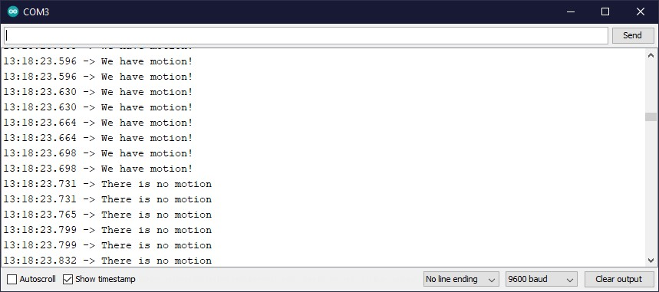

e) Run your program for three minutes. In that time, make sure the sensor can detect ‘Active’ as well as ‘Inactive’ data by creating some movement for it to detect. Retrieve the collected data as text file and save it your computer’s hard drive, naming it ‘lab2_motionData.txt’. Upload ‘lab2_motionData.txt’ with this lab report.

### **Q3: Temperature and Humidity Sensor**

1. Please refer to the provided ‘**Sensing Temperature and Humidity Activity Sheet**’ and follow the steps. Consider the given code in the activity sheet and fill the table below. The first row is completed for you.

|  |  |  |
| --- | --- | --- |
| term | explanation | example usage from code |
| variable | A variable is a place to store a piece of data. It has a name, a value, and a type. | float temp; |
| library | A library contains code pre-made code that the programmer can use in their projects. Libraries have code that is specifically meant for working with other components such as SD cards and sensors. | #include <DHT.h>  Dht.begin(); |
| comment | Comments are used as internal documentation for the programmer within a sketch. These are ignore by the compiler when verifying and uploading sketches | // I am a comment |

b) A spec of the DHT22 sensor is given in the link below. It mentions that the sampling rate is 0.5 Hz.

<https://tronixlabs.com.au/sensors/humidity/dht22-temperature-and-humidity-sensor-australia/>

* 1. What does the sampling rate mean?

The rate at which the sensor samples data

* 1. Where is this used in the Arduino code?

Line 17: Serial.begin(9600);

c) What is a simple strategy to test this program to make sure it is working as given in the requirements?

Use the serial monitor to check that the sensor is reading humidity and temperature data

d) Take a screenshot of your Serial Monitor displaying temperature & humidity sensor data logs. Add the image here.

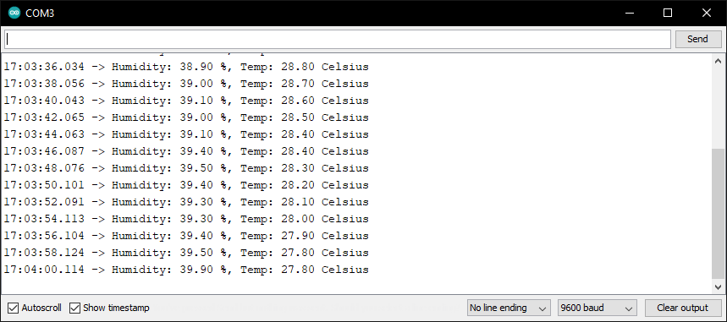

e) Run your program for five minutes. Retrieve the collected data as text file and save it your computer’s hard drive, naming it ‘lab2_temperatureData.txt’. Upload ‘lab2_temperatureData.txt’ with this lab report.

### 

### **Q4: Soil Moisture Sensor**

Please refer to the provided ‘**Sensing Soil Moisture Activity Sheet**’ and follow the steps.

1. Refer to the given code in DFRobotSoilMoisture.ino. What does the following line do?

val = analogRead(0);

This line gets the board to read signals coming in from an analog pin.

1. How is analogRead different than digitalRead?

[Hint: we used digitalRead in the code for HCSR505 PIR Motion detector]

analogRead can read values between 0 and 1023 whereas digitalRead can only read values 1 or 0.

1. What is a simple strategy to test this program to make sure it is working as given in the requirements?

Use the serial monitor to check that the sensor is reading moisture data

d) Take a screenshot of your Serial Monitor displaying soil moisture sensor data logs. Add the image here.

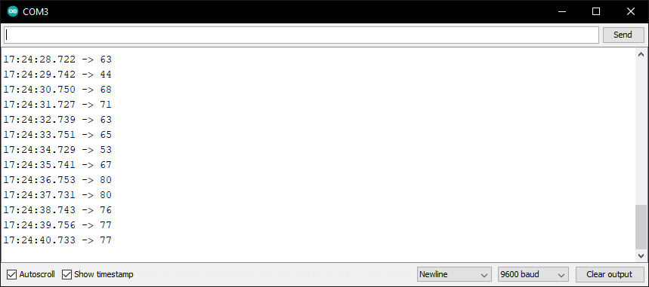

e) Run your program for three minutes. Experiment testing the sensor in the air, in water & wet tissue. Retrieve the collected data as text file and save it your computer’s hard drive, naming it ‘**lab2_soilMoistureData.txt**’. Upload ‘**lab2_soilMoistureData.txt**’with this lab report.

**Important: When you are finished, gently unplug the jumper cables from the Arduino pins and the sensor pins.**

## **Task 2 - Objective**

1. Use the provided dataset HumidityDataset.CSV on collection of Humidity values for location X. The file is available here: <https://drive.google.com/open?id=0B6VXEzM81LStczdRUjlnWjNEOEU>
2. Investigate the data for inconsistencies. These inconsistencies could include:
   1. Missing data, rows and column values
   2. Mismatched data fields
   3. Mismatched date formats
3. Propose ways to fix consistencies, these fixes could include:
   1. Propose and use default values
   2. Remove missing rows
   3. Fix data format mismatches
4. Fix the data

## Task 2- Submission Details

There are 2 questions in this task. Answer all of them in this document itself.

### **Q1: Once you have cleaned your data, submit the cleaned data file to unit site with this document.**

### **Q2: Submit brief details on which inconsistencies you have found, what was your approach for fixing them and discuss the Pros. and Cons of your approach, using the given table below:**

|  |  |  |
| --- | --- | --- |
| Inconsistencies found | Approach for fixing | Pros. and Cons of your approach |
| Some timestamps were not formatted correctly | Converted all the timestamps using text to format in Excel. Converted to dates to date format and times to time format. Split times into its own column | **Pros:** Timestamps and dates are now properly formatted and readable  **Cons:**  The dates format is slightly different but still the same nonetheless. |
| Some humidity levels were represented incorrectly or had an invalid value | Rows were removed | **Pros:**  Rows of invalid data removed  Incorrect representations fixed  **Cons:**  Removed data rows will no longer contribute to analysis of data. |
| One row was left completely blank | Row was removed | **Pros:**  Row removed without affecting other data  **Cons:**  N/A |

(You may add more rows to the table as required)